Checklist
This draft emergency plan template has several items highlighted that will need to be customized to the city/community/homeowners’ association (HOA) drafting their specific emergency plan. The checklist below summarizes the critical items that need to be addressed in the plan. The steering committee for each city/community/HOA should assign a person or agency to each of these items to orderly complete their evacuation plan. Each item in the checklist references a specific section or appendix in the plan. Those sections have highlighted text that should be considered by the assigned person/agency when completing the item. There is also text (i.e., Section 2) in this plan that is specific to the Ocean Hills community as a whole. If you are drafting a plan for a specific neighborhood or HOA, you should replace this text with text specific to your planning area.
Checklist | Responsible Agency/  Organization/Dept. | Date Assigned | Date Complete
Identify the lead and supporting agencies responsible for various activities during an emergency evacuation. See Section 3.
Develop a Public Information plan. See Section 5.
Identify Emergency Management Areas. See Section 6.
Develop a Traffic Management Plan. See Section 7 and Appendix II.
Identify transit dependent pick-up points and routes to service these pick-up points. See Section 8.
Identify transportation resources for transit dependent and access and functional needs population. See Section 8 and Appendix III.
Establish a transit dependent and access and functional needs registry. See Section 11.
Identify plans to accommodate pets at temporary shelters/ reception centers. See Section 12 and Section 14.
Establish Mutual Aid Agreement and draft letters of agreement/ memorandums of understanding. See Appendix IV.

City of Oceanside
Wildfire Evacuation Plan
for the
Ocean Hills Neighborhood

Prepared for:
Oceanside Fire Department
300 North Coast Hwy
Oceanside, CA 92054
By:
Name
Address
Email Address

Date

Signature Page

This document has been reviewed by:

Name | Agency/  Organization/Dept. | Signature | Date

Any questions, comments, and/or updates regarding this plan can be directed to:

Fire Marshal or Emergency Manager
Oceanside Fire Department
300 North Coast Hwy
Oceanside, CA 92054
ofdfireprevention@oceansideca.org
(760) 435-4101

Table of Contents

1 Purpose 1
2 Background and Objectives 1
3 Activities and Responsibilities 7
4 Public Alerting and Warning Systems 9
5 Public Information 13
6 Emergency Management Areas 15
7 Traffic Management 16
8 Transportation 19
9 Evacuation of Schools and Child Care Facilities 21
Schools 22
Child Care 22
10 Evacuation of Special Facilities 24
Religious Facilities 24
Senior Residences and Assisted Living 24
Residential Communities and Apartments 25
11 People with Access and Functional Needs 27
12 Evacuation of Animals 30
13 Power Outages 32
14 Reception Centers/Shelters 33
15 Repopulation Planning 34
APPENDIX I – Ocean Hills Communities & Evacuation Egress Routes 35
APPENDIX II – Traffic Management and Road Closure Strategies 39
APPENDIX III - Transportation Resources 42
APPENDIX IV – Supporting Plans, References & Letters of Agreement/Memorandums of Understanding 44

List of Figures and Tables

Figure 1. Location of Ocean Hills Neighborhood 4
Figure 2. Ocean Hills Fuel Vegetation Coverage & FHSZ 5
Figure 3. Historical Fires Near Ocean Hills 6
Figure I-1. Emergency Management Areas (Communities) Comprising Ocean Hills 34
Figure I-2. Special Facilities in Ocean Hills 35
Figure I-3. Evacuation Routes and CA-78 Access Points 36
Figure II-1. Traffic Control Point Locations and Congestion Patterns 39
Table III-1. Transportation Resources Needed 41

Purpose

This Evacuation Plan provides guidance for the evacuation operations of an affected population, typically involving 50 individuals or more, within the neighborhood of Ocean Hills during a wildfire event. The plan addresses the city department roles and responsibilities as well as the alert and warning systems and public information that could be utilized to notify and inform the affected population. The plan also outlines specific evacuation areas based on historical fire behavior and provides suggested evacuation routes. Temporary shelters/reception centers for evacuated populations are discussed as well as repopulation planning.

Background and Objectives

The City of Oceanside was incorporated in 1888 and is located in northern San Diego County along the Pacific Ocean. Oceanside boasts 3.5 miles of coastline, a small craft marina and is the 3rd largest city in San Diego County with almost 180,000 residents over 42 square miles. Oceanside is also host to a transit station with access to Amtrak, Metro Link, Coaster and Sprinter rail lines. Of the City’s 42 square miles, approximately 70 percent (18,429 acres) are privately owned and the remaining 30 percent (7,767 acres) of the City’s land area is owned by various public agencies.

Approximately 2,956 acres of land are classified as vacant and undeveloped based on 2007 existing land use data; approximately 66 percent (1,952 acres) is privately owned. Much of the disturbed areas in private ownership are the result of fire management activities, prior agricultural uses, and the removal of vegetation by brushing and grading prior to development. Many of the City’s planning neighborhood areas consist of the vacant and undeveloped lands.

The Neighborhood of Ocean Hills is one of 16 neighborhoods that comprise the City of Oceanside. Ocean Hills, with a population of approximately 7,300 and an additional 40,000 in the surrounding region, is located along the Southeastern boundary of the city near Calavera park and natural lands. Due to the close proximity of natural and undeveloped lands and the recent occurrence of wildfires within San Diego County, Ocean Hills residents are concerned with the vulnerability to fire of the Ocean Hills neighborhood. See Figure 1.

During a wildfire, the transportation system can become inadequate due to unsafe roadway conditions, abandoned vehicles blocking the roadway, and/or traffic congestion. Due to the proximity of Ocean Hills to natural and undeveloped lands and the recent occurrence of wildfires, Ocean Hills residents are concerned with the vulnerability of the neighborhood.

Figure 2 shows the fuel vegetation coverage and fire hazard severity zones (FHSZ) around Ocean Hills. Even though there is very limited fuel within the neighborhood, Ocean Hills is surrounded by vegetation to the west (Carlsbad Highlands Ecological Reserve) and to the southeast (Dawson Los Monos Canyon Reserve). Three historical wildfires have burned within these natural lands, as shown in Figure 3. The most recent wildfire took place almost 40 years ago inside Los Monos Canyon which did not reach Ocean Hills. There is only one historical wildfire that reached the neighborhood limits, which took place in 1979.

In an emergency, local officials may issue either an evacuation warning or an evacuation order.

An evacuation warning is the alerting of people in an affected area of potential threat to life and property. An evacuation warning considers the probability that an area will be affected within a given timeframe and prepares people for a potential evacuation order. Evacuation warnings are particularly necessary when dealing with a variety of issues such as large school populations or people with disabilities and access and functional needs. In a fast-moving fire there may not be sufficient time for first responders to issue an evacuation warning (prepare to evacuate).

An evacuation order requires the immediate movement of people out of an affected area due to an imminent threat to life.

Once an evacuation warning or order has been issued, residents and facility administrators should listen to, and comply with, directions provided by public officials and law enforcement to maintain a safe and streamlined evacuation process.

As discussed in the Executive Summary of the “Neighborhood of Ocean Hills Wildfire Evacuation Study” (KLD Engineering, P.C, Report KLD TR-1222, December 21, 2021), the evacuation times for the Ocean Hills neighborhood are dictated by the mobilization time or activities undertaken to prepare for the evacuation trip of the population at risk. Therefore, a periodic public information dissemination should be considered to encourage the public to prepare an emergency supply kit (“go-bag”) containing your
prepared family and pet’s necessary items to reduce mobilization time. The County of San Diego Office of Emergency Services has a free, printable, All Hazards
Family Disaster Plan and Survival Guide at: ReadySanDiego.org/make-a-plan.

The objectives of this Evacuation Plan are to provide the Ocean Hills neighborhood with a plan that expedites and guides:

- Emergency alert and warning of affected population
- Disseminating emergency planning information to the public (“Public Information”)
- Movement of people and animals from the hazardous areas
- Traffic flow out of evacuation areas
- Coordinated transportation for those without access to a vehicle and those with Access or Functional Needs
- Perimeter control and security for the evacuated areas

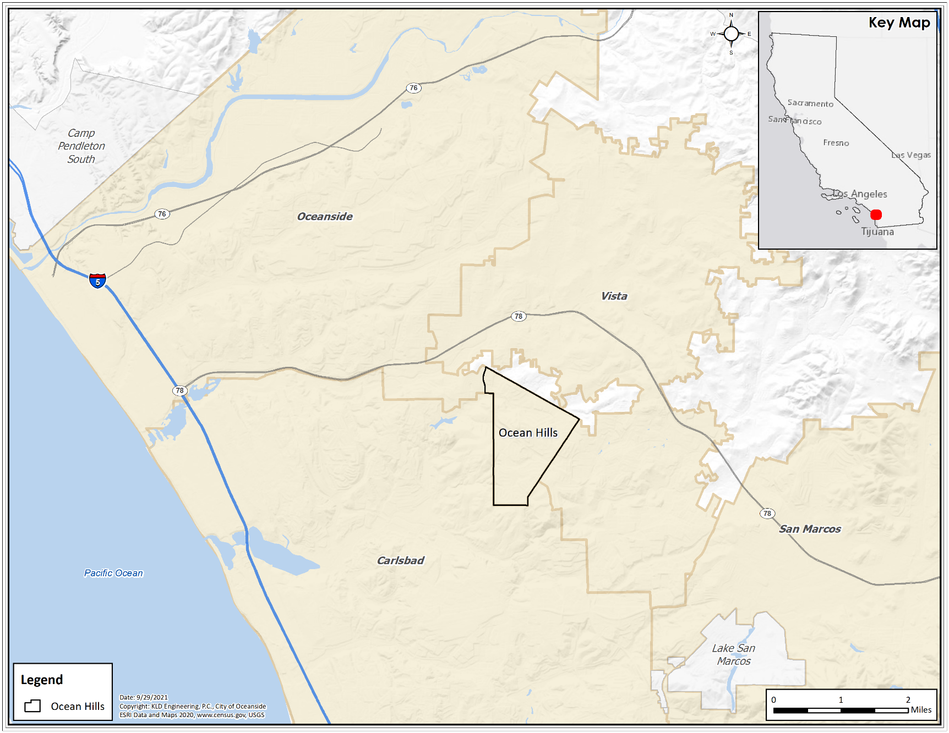
Figure 1. Location of Ocean Hills Neighborhood
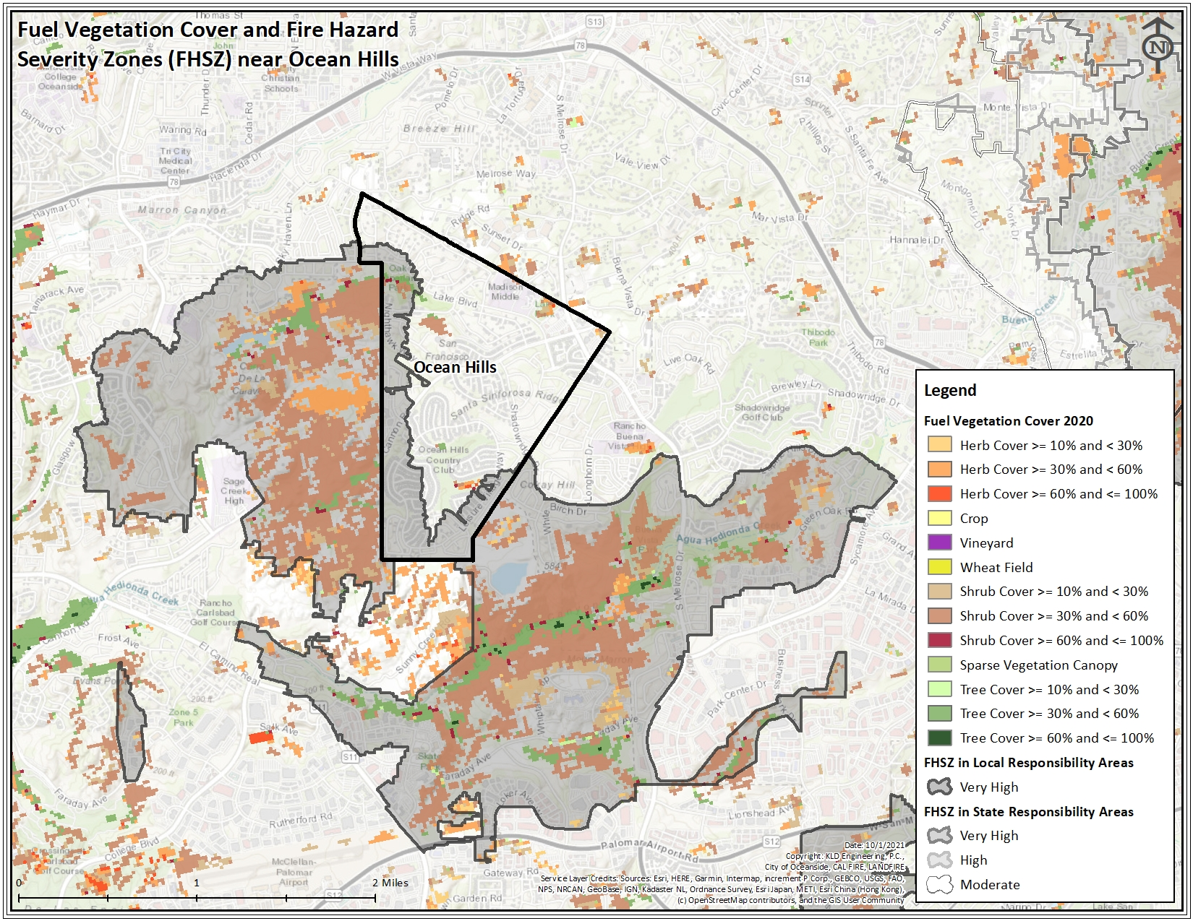
Figure 2. Ocean Hills Fuel Vegetation Coverage and Fire Hazard Severity Zones
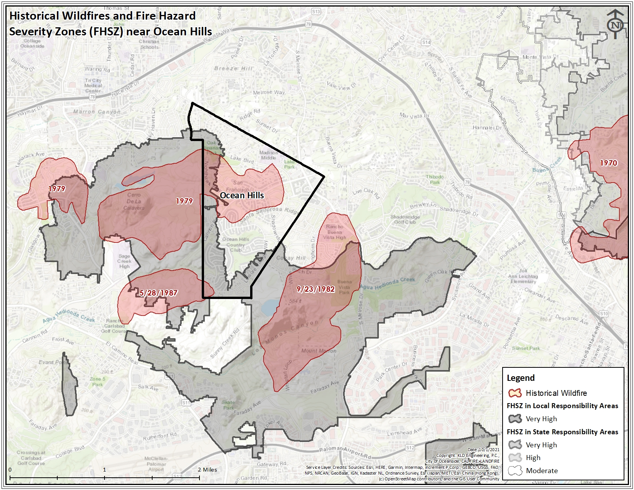
Figure 3. Historical Fires Near Ocean Hills

Activities and Responsibilities

The tables below list the lead and supporting agencies responsible for various activities during an emergency evacuation. The following should be identified for each agency:
- Agency name
- Point of contact (POC) at the agency
- Several ways of contacting the POC
  - Cellular phone
  - E-mail address
  - Home phone
- Backup points of contact, as needed

Assess Event Impact on Public Health and Determine Protective Actions
Lead Agency | Support Agencies
Stakeholders to fill in | Stakeholders to fill in

Identify Evacuation Routes and Manage Traffic
Lead Agency | Support Agencies
Stakeholders to fill in | Stakeholders to fill in

Communicate with the Public
Lead Agency | Support Agencies
Stakeholders to fill in | Stakeholders to fill in

Provide Evacuation Transportation Assistance
Lead Agency | Support Agencies
Stakeholders to fill in | Stakeholders to fill in

Open and Operate Shelters/Reception Centers
Lead Agency | Support Agencies
Stakeholders to fill in | Stakeholders to fill in

Public Alerting and Warning Systems

It is important that disaster information be available in a variety of accessible formats. Available communication tools/capabilities which may be used to notify the general public about the need to evacuate or shelter-in-place include:

• Emergency Alert System (EAS)
• Community Emergency Notification System
• AlertSanDiego
• Nixle
• Accessible AlertSanDiego
• 2-1-1 San Diego
• Emergency websites, including www.sdcountyemergency.com
• SD Emergency App for smartphones
• Wireless Emergency Alerts (WEA)
• Television including County Television Network
• Radio
• Public address systems
• Helicopters equipped with bullhorns
• Low power local radios
• Police vehicles equipped with public address systems
• Door to door notification
• Dynamic or Variable Message Signs

- Emergency Alert System (EAS)
- EAS is a national public warning system.
- Broadcasters, satellite digital audio service and direct broadcast satellite providers, cable television systems, and wireless cable systems are required to provide a communications capability to address residents and visitors within 10 minutes during an emergency.
- The primary Emergency Alert System station for San Diego County is radio station KOGO AM 600. The secondary station is KLSD AM 1360. The local television station is KOCT channel 18/19.

- AlertSan Diego – AlertSanDiego is for registering your cell phone number, Voice over IP (VoIP) phone number, and email address only. Listed and unlisted landline phone numbers are already included in the database and do not need to be registered. The County of San Diego, in partnership with Blackboard Connect Inc., has instituted a regional notification system that will be able to send telephone notifications to residents and businesses within San Diego County impacted by, or in danger of being impacted by, an emergency or disaster. This system, called AlertSanDiego, will be used by emergency response personnel to notify those homes and businesses at risk with information on the event and/or actions (such as evacuation, shelter in place, gas leak, missing person, etc.) they are being asked to take. The system utilizes the region's 9-1-1 database, provided by the local telephone company(ies), and thus is able to contact landline telephones whether listed or unlisted. It is Teletype/Telecommunication Device for the Deaf (TTY/TDD) capable.

Because the system uses the 9-1-1 database, only landline numbers are in the system. If you have a VoIP or cellular telephone and would like to be notified on that device, or if you would like an email notification, you must register those telephone numbers and/or email addresses for use by the system.

Residents can register for AlertSD using the web address below:
https://www.readysandiego.org/content/oesready/en-us/alertsandiego.html

The AlertSan Diego system also provides messaging for residents of San Diego County who are deaf, blind, hard of hearing, and deaf/blind before, during, and after a disaster. Residents can register for Accessible AlertSanDiego notifications by selecting the Accessible Option during registration at www.readysandiego.org/alertsandiego/

- San Diego (SD) Emergency App – The SD Emergency App contains disaster preparedness information, interactive checklists to help you create your emergency plan, build an emergency supplies kit, and when disaster strikes, the SD Emergency App will keep you and your family informed with emergency updates, interactive emergency maps, and shelter locations.

The County of San Diego Office of Emergency Services (OES) created the SD Emergency App to better prepare and inform San Diego County residents and visitors about disasters. With SD Emergency, the tools you need to plan, prepare, and respond in an emergency are right at your fingertips.

Residents can download the SD Emergency App for iPhone on the Apple App store or for Android in Google play.

• Wireless Emergency Alerts (WEA) - authorized public safety officials send WEA alerts regarding public safety emergencies – such as severe weather, missing children, or the need to evacuate – through FEMA's Integrated Public Alert and Warning System (IPAWS) to participating wireless carriers, which then push the alerts to compatible mobile devices (cellphones) in the affected area.

The alerts are broadcast to the geographic area affected by an emergency. This means that if an alert is sent to a specific area in California, WEA-capable mobile devices located in that area at the time the alert is sent can receive the alert, even if they are roaming or visiting from another area.

Consumers do not need to sign up for this service. WEA allows government officials to send emergency alerts to all subscribers with WEA-capable devices if their wireless carrier participates in the program.

Ocean Hills Emergency Alert and Warning Systems Opt-in Statistics – As discussed in Appendix A of the “Neighborhood of Ocean Hills Wildfire Evacuation Study” (KLD Engineering, P.C, Report KLD TR-1222), approximately 66% of Ocean Hills residents are opted into their local emergency alert systems. The majority (57%) of the neighborhood residents who are registered are opted into Alert San Diego.

Public Information

During a wildfire event, it is important to maintain situational awareness. Public information should provide residents with multiple ways to know if they are in an area under an evacuation order. Multiple, authoritative messaging channels that include photos or links to other visual information about the hazard should be used and encourage individuals to share this information with friends and families. Frequent updates should be provided with information that reduces stress of the unknown related to evacuation. The following should be considered when developing a public information plan:
- Format of the public information:
  - Printed
    - Calendar
    - One-pager
    - Multi-page brochure
    - Postcard with scannable QR codes or links to county/local emergency planning websites
  - Electronic
    - Website
    - Mobile application
    - Social media platform
    - E-mail
- Periodicity of the dissemination of the public information
  - Weekly
  - Monthly
  - Semi-annually
  - Annually
- Maintenance of the public information – who will be responsible for updating and disseminating the public information
- Financing – who will be responsible for funding the maintenance and dissemination of the public information

The following are sources of information before and during an emergency.

Websites
SDcountyemergency.com
- During a disaster, this website will be promoted by the County of San Diego to the media/public as the official disaster information website.
- The site will include:
  - Emergency maps, evacuation areas, disaster perimeter, shelter locations, Local Assistance Center locations, road closures, press releases, and other pertinent disaster-related information.
ReadySanDiego.org
- Before a disaster strikes, this website provides preparedness information, resources and tools.
2-1-1 San Diego (https://211sandiego.org)
- Provides a 24/7 toll-free hotline connected to a highly trained team providing up-to-date information during an emergency.
- Vital information about conditions and services such as road closures, evacuation routes, shelters and more.
- If there is a threat to life or safety, call 9-1-1 immediately.

Social Media
- Twitter
  - www.twitter.com/readysandiego (@readysandiego) (English)
  - www.twitter.com/listosandiego (@listosandiego) (Spanish)
- Facebook
  - www.Facebook.com/ReadySanDiego

Emergency Management Areas

Emergency Management Areas are typically defined to divide a large potential area at risk into smaller areas. The Emergency Management Area boundaries typically follow political (city, town or county boundaries) or geographical boundaries (river, major roadway) to facilitate identification of the area by the public. During an emergency, one, several, or all Emergency Management Areas may be advised to evacuate depending on the extent of the emergency. This plan divides the community of Ocean Hills into 14 Emergency Management Areas. Most of the area boundaries follow Homeowner’s Association (HOA) boundaries. A map of these areas and the recommended evacuation routes are provided in Appendix I.

The Oceanside Fire Department, in collaboration with the City of Oceanside and San Diego County Office of Emergency Services will determine which areas will be evacuated. These Areas can be changed during an incident as necessary to ensure the safety of life, property, and the environment.

The following should be considered when developing Emergency Management Areas for your city/community/HOA:

- Should the city/community/HOA be divided into various emergency management areas, or treated as a whole?
- If dividing the city/community/HOA up:
  - Use identifiable political (i.e., town boundary), geographical (i.e., river) or human-made (i.e., a named street) boundary that can easily be communicated to the public. For example, everyone east of River X evacuates.
  - Do not bisect neighborhoods to the extent practical as this can lead to confusion in emergency messaging
  - Consider risk – those areas closest to the ridgeline or fuel should be given a higher evacuation priority than those areas with limited fuel

Traffic Management

The purpose of traffic management in an emergency is to:
- Facilitate evacuating traffic movements that safely expedite travel out of the impacted area; and
- Discourage traffic movements that move evacuating vehicles in a direction which takes them into the impacted area, or which interferes with the efficient flow of other evacuees.

Ocean Hills has five primary ingress/egress routes, which are shown in Appendix I. The key finding of the “Neighborhood of Ocean Hills Wildfire Evacuation Study” (KLD Engineering, P.C, Report KLD TR-1222) is that the available roadway supply (evacuation routes and roadway network) is more than sufficient to service the evacuation demand (number of evacuating vehicles) within the neighborhood in a timely fashion.

The roadway system surrounding Ocean Hills is robust. Cannon Rd is an excellent, high‐capacity roadway with two outbound lanes. The roadways servicing Ocean Hills provide access to six different interchanges (Vista Way/Plaza Dr, S Emerald Dr, Vista Village Dr, Civic Center Dr, Mar Vista Dr, and Sycamore Ave) with CA‐78, which is a high‐capacity, high‐speed, limited access freeway. A map of these interchanges is included in Appendix I. The only prolonged traffic congestion within the area is at the Ocean Hills Country Club (OHCC), which is somewhat capacity constrained given the number of people living in the community and only two connections (Leisure Village Dr and Ocean Hills Dr) to the surrounding roadway system.

There are many strategies available that can be implemented during an evacuation to facilitate traffic flow and potentially reduce traffic congestion and the overall evacuation time. Strategies that could be implemented for the Ocean Hills neighborhood include establishing Traffic Control Points (TCP), the use of Dynamic Message Signs/Variable Message Signs (DMS/VMS), and the use of other Intelligent Transportation Systems (ITS) technologies.

Traffic Control Points – As discussed in Appendix B of the “Neighborhood of Ocean Hills Wildfire Evacuation Study” (KLD Engineering, P.C, Report KLD TR-1222), establishing TCPs along Shadowridge Drive could facilitate the flow of evacuation traffic leaving the Ocean Hills Country Club (OHCC). TCPs may be established along Shadowridge Drive at the following intersections: 1) Ocean Hills Drive, 2) Rosewood Street, and 3) Longhorn Drive. These three TCPs could relieve the localized congestion along Shadowridge Drive and within OHCC.

Dynamic Message Signs/Variable Message Signs - Vehicles will be traveling through Oceanside (external‐external trips) at the start of an emergency. External traffic vehicles will utilize CA‐78 to pass through the area. DMS/VMS can be strategically positioned outside of the hazard area at logical diversion points to attempt to divert traffic away from CA-78. Doing so will reduce congestion along the main thoroughfare of CA-78 which will facilitate the flow of evacuation traffic leaving Ocean Hills and utilizing the access ramps to CA-78.

Traffic signal coordination and timing plans are intended to maximize traffic flow in the outbound direction during an evacuation effort. Depending on the extent of the evacuation, coordination may be necessary both locally and regionally to “re-time” the traffic signal systems. Additionally, it is important to identify the number of non-programmed signals along the evacuation routes. These signals can be plugged into non-centrally programmed traffic signal boxes which will then generate flashing yellow and red lights to help manage traffic. Individual jurisdictions should determine whether local traffic signals can be controlled from a central location as well as the availability and capability of back-up power sources.

Intelligent Transportation Systems include a broad range of technologically based tools that enable transportation and emergency managers to monitor traffic conditions, respond to capacity reducing events, and provide real-time road conditions. For the Ocean Hills neighborhood, these technologies could include DMS/VMS and Highway Advisory Radio to recommend a different evacuation route due to congestion.

And finally, designated markings and signs will play a key role in accomplishing a safe and efficient evacuation. Signs, flags, and other markings can be used to provide guidance and information to evacuees along the route along with road barriers used in conjunction with other transportation strategies to ensure evacuees remain on designated evacuation routes or are blocked from entering closed areas.

Appendix II further discusses traffic management strategies.

The following should be considered when developing a TMP for your city/community/HOA:
- Are there any bottlenecks or chokepoints that should have manual traffic control at them during an emergency? Note, most modern traffic signals are as efficient as manual traffic control during an emergency evacuation. Do not assume that all traffic signals would benefit from manual traffic control during an emergency.
- How many people trained in performing traffic control (typically law enforcement) are available to implement the TMP during an emergency?
- What equipment (cones, barriers, barricades) is available to implement the TMP during an emergency?
- Where is the equipment stored and who can access the equipment if needed?
- Identify if there are dynamic message signs/variable message signs available to communicate important information to the public during an emergency, identify where these signs are, who controls the signs and how to mobilize the signs (if applicable) during an emergency.
- How quickly can equipment and manpower be mobilized to implement the TMP during an emergency?

Transportation

The primary mode of transportation that will be used during evacuation will be privately owned automobiles. Evacuation routes to be followed are depicted in Appendix I.

Public and private transportation agencies under mutual aid or Letters of Agreement (LOAs)/Memorandums of Understanding (MOU) will assist residents with safe and timely evacuation. Appendix III lists transportation resources currently available to assist with the evacuation of the Ocean Hills neighborhood.

The County of San Diego has developed LOAs/MOUs with regional transportation services providers which includes the provision of bus drivers and paratransit operators. In addition, the County works on establishing and maintaining working relationships with partner organizations including advocacy organizations, agencies that serve the transportation-dependent populations, and faith and community-based organizations.

It is critical that modes of available transportation are identified that can help evacuate people with disabilities and others with access and functional needs during an emergency. Transportation that can accommodate wheelchairs, scooters, or other mobility aids should be sought, as appropriate.

Pickup points along major evacuation routes should be identified where individuals without transportation resources can gather and be provided transportation to temporary shelters/reception centers.

These pickup points should be large, well-known sites such as shopping centers, libraries, and schools. Proximity to evacuation areas is also an important consideration. The overall number and location of pickup points should be based on the population that needs to be accommodated and with the understanding that evacuees will reach these locations by foot.

During the evacuation process, it may be necessary to provide assistance to non-ambulatory residents or those who require mobility assistance, assistance with directions, supervision, and language interpretation. Law enforcement personnel should ensure these areas are well marked through the use of signs or other forms of identification.

Routes should be identified to service the identified pickup points. Sufficient transportation resources and operators should be identified to service these routes. Operators should be periodically trained. To the extent practical, existing bus/trolley/train stops, existing bus/trolley/train routes, and existing bus/trolley/train operators should be leveraged.

Some cities/communities/HOAs may have very few people who are transit dependent or have access and functional needs. It may be more efficient for these areas to have police cruisers or transit vehicles pick people up at their homes and transport them directly to reception centers/shelters.

Evacuation of Schools and Child Care Facilities

Public schools and school districts are required to have emergency plans in place to safeguard students, staff and visitors. Public schools may or may not have adequate resources, including transportation, to support their students and staff during an evacuation order. Public schools may evacuate or relocate to another school site during an emergency. Parent and student reunification orders are the responsibility of the school district and must be obtained and communicated to others in an expeditious and inclusive way.

Private schools are responsible for their students, staff, etc.; however, they may require support including transportation. They should maintain their own Emergency Plans.

Students at private and public schools in Ocean Hills walk or bike to school each day or get a ride from their parents/guardians. In an emergency, they will likely walk/bike home or be picked up by their parents prior to evacuating. Nonetheless, some emergencies may warrant evacuating students by bus to temporary shelters or reception centers. Appendix III further discusses transportation resources needed for evacuation.

There are four possible scenarios for schools: evacuation warnings, evacuation orders, sheltering-in-place and voluntary evacuations/early dismissals. An evacuation warning allows for preparation in the event of a potential subsequent evacuation order. An evacuation order requires immediate movement of schoolchildren out of an affected area. In some instances, when an evacuation may put students and staff at greater risk, it may be necessary to shelter-in-place. This may be the most appropriate protective action during a fast moving, approaching wildfire, when leaving school grounds poses more of a danger than remaining in place. In evolving situations, local authorities may not issue an evacuation warning or order early in the event, only to do so later when the event poses a greater threat. It may be best for some schools to issue an early dismissal and voluntarily evacuate on their own due to unique characteristics and circumstances.

Schools
If any portion of the Ocean Hills neighborhood is evacuated, schools (if in session) should be advised so they do not release children and end up with unaccompanied minors without a home to go to. Schools will keep the children on campus, if safe, until guardians arrive to pick them up. The schools in Ocean Hills are listed below:

New Venture Christian School
4000 Mystra Dr, Oceanside, CA 92056
(760) 477-8315

Lake Elementary School
4950 Lake Blvd, Oceanside, CA 92056
(760) 945-5300

Madison Middle School
4930 Lake Blvd, Oceanside, CA 92056
(760) 940-0176

Montessori School of Oceanside
3525 Cannon Rd, Oceanside, CA 92056
(760) 941-3883

Child Care
Similar to schools, childcare facilities should be advised of an evacuation. Childcare facilities will keep the children on campus, if safe, until guardians arrive to pick them up. If children cannot be picked up in a timely fashion, the childcare facilities may require transportation assistance to be evacuated. The childcare facilities in Ocean Hills are listed below:
Lucy's Family Childcare
4981 Marin Dr, Oceanside, CA 92056
(760) 224-1868

Evacuation of Special Facilities

Religious Facilities
Religious facilities should be advised of an evacuation. People attending religious facilities would either walk or drive to these facilities. In an emergency, they would either need to return home and evacuate in their vehicle or they would evacuate directly from the facility parking lot. The religious facilities in Ocean Hills are listed below:
New Venture Grace Church
4000 Mystra Dr, Oceanside, CA 92056
(760) 721-7777

St. Thomas More Catholic Church
1450 S Melrose Dr, Oceanside, CA 92056
(760) 758-4100

Senior Residences and Assisted Living
Senior Residence and assisted living facilities should be advised of an evacuation. People living in these facilities might require buses, wheelchair transport vehicles or ambulances. The staff should remain at these facilities to help facilitate the evacuation and load passengers onto special transport vehicles. The staff should either accompany passengers in the buses, wheelchair transport vehicles or ambulances or evacuate in their personal vehicles. The senior residence and assisted living facilities in Ocean Hills are listed below:

Ocean Hills Senior Living (Protea Phase I)
4500 Cannon Rd, Oceanside, CA 92056
(760) 295-8515

Aegis Living Shadowridge
1440 S Melrose Dr, Oceanside, CA 92056
(760) 444-0758

Residential Communities and Apartments
While residents of Ocean Hills will likely be notified of an evacuation through the various technologies discussed in Section 4, management and homeowners’ associations at residential communities and apartments should be advised of an evacuation. Most people living in these communities and apartments will evacuate in personal vehicles, though some may require transportation assistance (buses). The transit dependent population that requires transportation assistance can congregate along major evacuation routes to be picked up by buses. Households might have a vehicle that is with a commuter that cannot return home during an evacuation. These households would also require transportation assistance. The residential communities and apartments in Ocean Hills are listed below:

Seagate Terrace Community
GRG Management
(760) 720-0900 x103

Ocean Terrace Community
Dennis Schwander, dkschwan@cox.net
John O’Donnell, civilam1@cox.net

Ocean Hills Country Club
Wendy Panizza
(760) 758-7080

Southridge Estates
Associa – (760) 918-8040
Barbara Day, Barbara.Day@associa.us

The Summit
Lindsay Management Co. (760) 436-1144
Kelly Jones, kelly@lindsaymgt.com

Ridgeview Estates
HOA Management (760) 239-6624
Christina@mydaymanagement.com

Windrift Apartments
3500 Windrift Way, Oceanside, CA 92056
(442) 245-5178

Broadmore Hills
Lindsay Management Co. (760) 436-1144
kathy@lindsaymgt.com

Terramar
AAM Management (760) 688-3127
Kayla Johnson
KMJohnson@AssociatedAsset.com

People with Access and Functional Needs

Evacuation of people with disabilities and those with access and/or functional needs takes more time, effort and resources than evacuation of the general population. Thus, early evacuation triggers are an important aspect of effectively evacuating these residents.

As discussed in Appendix A of the “Neighborhood of Ocean Hills Wildfire Evacuation Study” (KLD Engineering, P.C, Report KLD TR-1222), 41 of the 656 households (6.25%) surveyed in Ocean Hills indicated they would require transportation assistance (bus, van, wheelchair accessible vehicle, ambulance) to evacuate. The number of access and functional needs people will fluctuate over time. Nonetheless, a plan should be in place to evacuate this population during an emergency. People with access and functional needs include:

- People with disabilities are not necessarily among the portion of the population that may need evacuation assistance. Many people with disabilities live independently, are fully self-sufficient and will self-evacuate.

- People with disabilities can lose their support system and become dependent on assistance if separated from their mobility device or durable medical equipment. Such equipment is essential to maintaining independence and will be evacuated with the user whenever possible.

- Situations may arise where attempting to transport certain types of medical equipment or devices with an individual is impractical due to the physical size or volume of the equipment and the space available on the evacuation vehicle. In these cases, responders should be prepared with additional vehicles specifically for the transport of such equipment. Those vehicles should closely follow the evacuation vehicle of the affected individual(s).

- Many people who are ordinarily self-sufficient may have functional needs due to physical or emotional trauma or temporary lack of resources or accommodations.

- Transit-dependent populations (e.g., people with disabilities and those with access and/or functional needs and households without a vehicle) will require public transportation to evacuate. This population group can congregate along major evacuation routes to be picked up by buses; see Section 5 of the KLD TR-1222.

- Transportation able to accommodate people in wheelchairs, scooters, or other mobility aids must be made available. Mobility devices and durable medical equipment should be transported with the evacuee. Services animals will always be transported with their owner.

- People that are blind or have low vision will need additional assistance during transport because they cannot rely on their traditional orientation and navigation methods. Evacuees with cognitive disabilities, as well as people with dementia, should be transported with their caregivers or other mental health professionals, when possible, for their own safety.

- Buses and paratransit vehicles will most likely be the primary resources used to evacuate people with critical transportation needs. Medical transportation should be reserved for those with injuries and acute medical issues.

- Consider an “Access and Functional Needs Registry” where residents can self-disclose disabilities and access and functional needs, including the transit dependent population who do not own or have access to a private vehicle for evacuation. This registry can be a web-based registration, a mail-in postcard to a governmental agency, or a phone number to call. This registry can then be consulted as part of public outreach prior to, during, and following a major emergency. The assistance and type of vehicle (bus, wheelchair transport, ambulance, personal vehicle) needed to assist in evacuation should be identified.

Evacuation of Animals

Service animals are essential to the continued independence of persons with access and functional needs and should be evacuated with the person. The Americans with Disabilities Act (ADA) requires that service animals be permitted in any area accessible to the general public. This includes public transportation, shelters, and any other location where evacuees may be present.

- The Pets Evacuation and Transportation Standards (PETS) Act of 2006 was established and amends the Stafford Act. PETS require that evacuation plans consider the needs of individuals with household pets (specifically small animals such as dogs and cats) and service animals, prior to, during, and following a major disaster or emergency. Livestock, exotic pets and other large animals are not covered by the PETS Act.

- North County Transit District (NCTD) rules state service animals (e.g., seeing-eye dogs) are permitted onboard at all times. Household pets are permitted onboard during emergency evacuations if contained within a protective carrier that prevents the animal from interacting with other passengers.

- In the event pets are not properly caged, or the pet carrier is too large to fit on the transit trailer, the San Diego Humane Society may be able to provide trailers and cages to support the movement of animals. In such cases, the agency will take the animals to the animal shelters, allowing owners to collect their pet once the emergency situation has passed.

- Movement of restricted animals and exotics is the responsibility of the license
holder. The California Department of Fish & Wildlife coordinates with nongovernmental organizations to address wildlife and exotic animal shelter and rescue in the event of an emergency.

As discussed in Appendix A of KLD TR-1222, approximately 43% of the households within Ocean Hills have pets and/or animals. Of the households that own pets and/or animals, nearly all (99%) of them indicated that they own a domesticated animal (or household pet). Nearly all (99%) of households that own pets and/or animals would evacuate with their pets and they have sufficient room in their vehicles for their pets. 18% of the households with pets will take their pets with them to a temporary shelter/reception center.

Power Outages

For public safety, the electric utility in the area may turn off electricity in certain areas when forecasted weather conditions (such as gusty winds or dryness), heighten wildfire risks. These planned power shutoff events called Public Safety Power Shutoffs (PSPS) may disrupt your power supply, so it is important to be prepared and have backup plans. TV, radio, cell phones, landlines and electrical appliances such as refrigerators that rely on electrical power may be impacted. Keep in mind that traffic signals in the neighborhood could also be impacted.

Below are suggested steps to follow to minimize the impact of these shutoffs:

- Build or restock an emergency kit. Include food, water, flashlight, first aid kit, cash, a battery-operated radio and a phone charger that does not need an electrical outlet. Also include a supply of medications you take. Keep an up-to-date list of all your prescription medications. Include name, dosage amounts and known allergies. If you use refrigerated medications, you’ll need to make special plans to ensure they don’t spoil when you don’t have power.
- Make sure you have enough medication, as shutoffs may affect your pharmacy's electricity and ability to fill prescriptions. Please contact your pharmacy before the planned shutoff to refill your medication if needed.
- Keep electronic communication devices fully charged. If you lose power, minimize your use of these devices. Use your vehicle(s) to charge devices when necessary. Determine where the closest unaffected areas are where you can charge devices.
- If you use medical equipment that runs on power, contact your medical equipment provider. They may be able to help you get alternative devices.
- Sign up for Electric Utility alerts. Call their toll free number or visit their website. They will alert you in case of a planned power shutoff.

Reception Centers/Shelters

Temporary shelters/reception centers can serve as temporary safe zones for evacuees, but they generally do not provide any services, such as food, water, restrooms, etc. Locations for these centers should be considered prior to any emergency. These centers could include auditoriums in schools, conference rooms in buildings/hotels, or houses of worship.

Emergency shelters are opened when at least one overnight stay is necessary. Basic services are provided at emergency shelters, which include meals, shower facilities, dormitory management, health, and behavioral health services.

Coordination of emergency shelter facility selection and operations will occur at the County level, in coordination with the American Red Cross (ARC), affected incorporated cities and relevant partner organizations/agencies that may own/operate the facilities, such as school districts. Shelter sites will be selected from the ARC National Shelter System (NSS) based on the assumption that the public will want to be sheltered as close as possible to their neighborhood. Once a site is selected, the shelter will generally be opened and managed by the American Red Cross with support from the County of San Diego and affected incorporated cities.

As discussed in Section 12, some households will bring their family pets to temporary shelters/reception centers. Plans to accommodate pets at temporary shelters/reception centers should be developed, and should at least consider:
- Will pets be allowed?
- If yes:
  - Space needed for animals
  - Food and water
  - Bathroom needs
  - Separation of those with animals from those without for allergy reasons
  - Safety of pets and people

Repopulation Planning

Repopulation criteria shall take into account emergency worker safety and the community needs. Control of repopulation to an evacuated area shall be accomplished through collaboration between emergency management, law enforcement and fire personnel and coordinated with media releases and instructions.

Local residents may be allowed to repopulate with escorts or while cleanup operations and infrastructure repair continue, if the situation allows.

Coordination with assisting and cooperating agencies is critical to the success of repopulation planning. Ultimately, it is a law enforcement decision based on fire department input to approve repopulation of citizens back into an area previously closed or evacuated.

APPENDIX I – Ocean Hills Communities and Evacuation Egress Routes

The Neighborhood of Ocean Hills is one of the 16 neighborhoods that comprise the City of Oceanside which is located in northern San Diego County along the Pacific Ocean. There are approximately 7,700 permanent residents in Ocean Hills according to the 2020 Census. Ocean Hills is located in the southeastern portion of the city near Calavera Park and natural lands. Ocean Hills is divided into 14 communities/homeowners’ associations (HOAs) with distinct demographic characteristics. Figure I-1 displays each individual community/HOA within Ocean Hills.

There are three schools, two preschools/daycares, two religious centers, two senior living facilities and one golf course within Ocean Hills. Figure I-2 displays the name and location of each of these facilities.

Figure I-3 displays the five primary ingress/egress routes of Ocean Hills. The key finding of KLD TR-1222 is that the available roadway supply (evacuation routes and roadway network) is more than sufficient to service the evacuation demand (number of evacuating vehicles). The roadway system surrounding Ocean Hills is robust. Cannon Rd is an excellent, high-capacity roadway with two outbound lanes. The roadways servicing Ocean Hills provide access to six different interchanges (Vista Way/Plaza Dr, S Emerald Dr, Vista Village Dr, Civic Center Dr, Mar Vista Dr, and Sycamore Ave – see I-3) with CA‐78, which is a high‐capacity, high‐speed, limited access freeway.
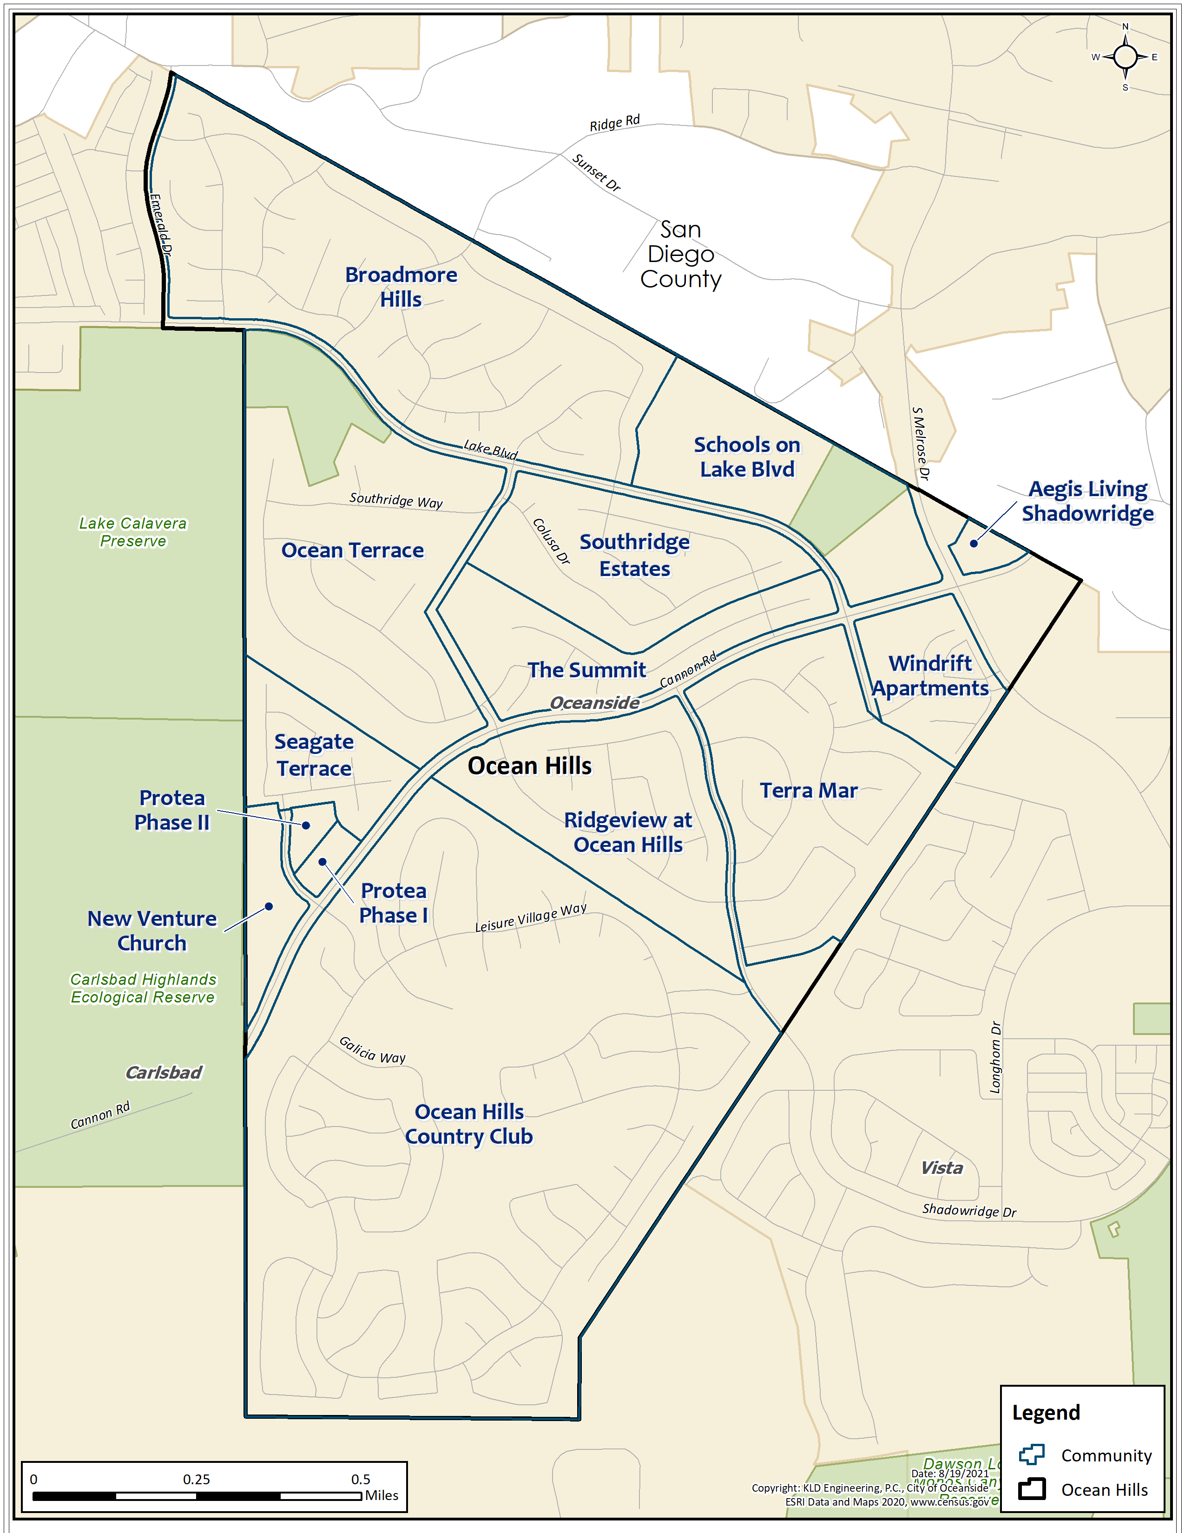
Figure I-1. Emergency Management Areas (Communities) Comprising Ocean Hills
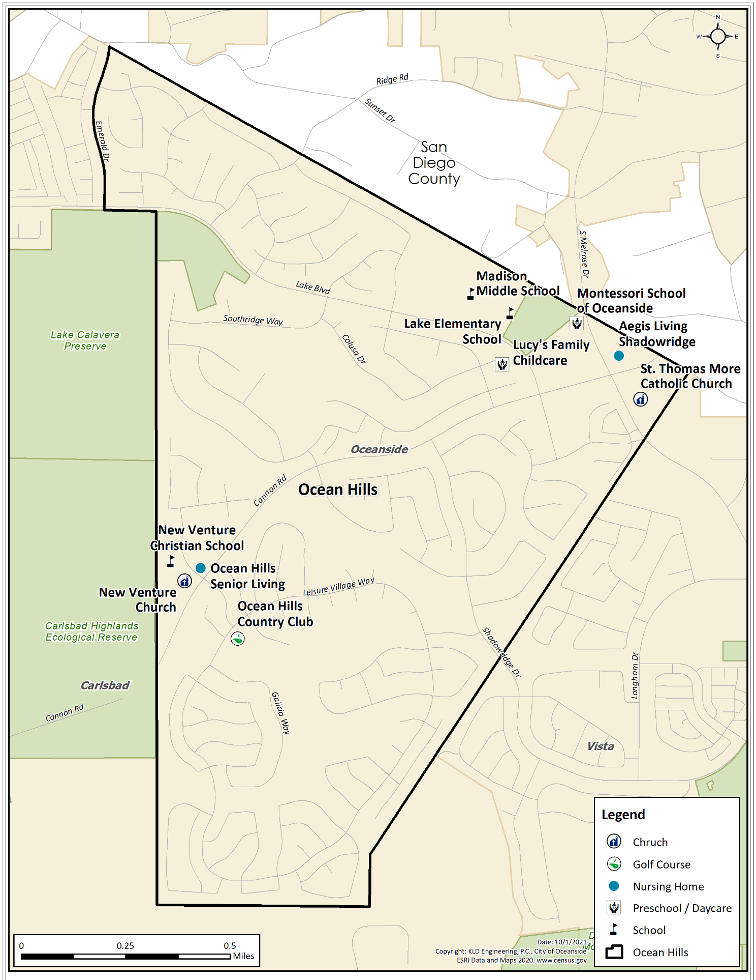
Figure I-2. Special Facilities in Ocean Hills
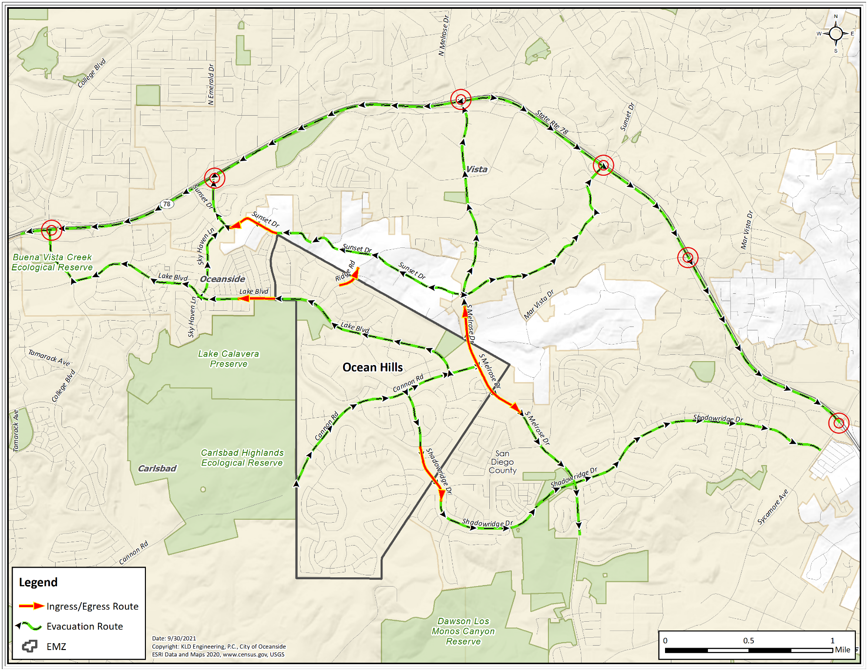
Figure I-3. Evacuation Routes and CA-78 Access Points

APPENDIX II – Traffic Management and Road Closure Strategies

A Traffic Management Plan (TMP) is typically designed for an area that is prone to wildfires to expedite the movement of evacuating traffic during an emergency. The resources required to implement this strategy include:

- Personnel with the capabilities of performing the planned control functions of traffic guides (preferably, not necessarily, law enforcement officers).
- Guidance is provided by the Manual of Uniform Traffic Control Devices (MUTCD) published by the Federal Highway Administration (FHWA) of the U.S.D.O.T. All state and most county transportation agencies have access to the MUTCD, which is available on-line: http://mutcd.fhwa.dot.gov which provides access to the official PDF version.
- A written plan that defines all Traffic Control Point (TCP) and Access Control Point (ACP) locations, provides necessary details and is documented in a format that is readily understood by those assigned to perform traffic control. TCPs are typically established within the area of risk to expedite the flow of traffic out of the area. ACPs are typically established on the boundary of the area of risk to stop the flow of traffic into the area.

The functions to be performed in the field are:
- Facilitate evacuating traffic movements that safely expedite travel out of the area at risk.
- Discourage traffic movements that move evacuating vehicles in a direction which takes them significantly closer to the area of risk, or which interferes with the efficient flow of other evacuees.

As discussed, in Appendix B of KLD TR-1222, there are three TCP locations that reduce the localized congestion within Ocean Hills Country Club and relieve the traffic congestion along Shadowridge Road. The TCP locations and predicted congestion patterns during evacuation are shown in Figure II-1.

Road closures may be necessary during an evacuation if flames or smoke present dangerous conditions. Signage and/or barricades should be positioned accordingly if time and resources permit. Detour routes should be established and communicated to the public through signage or police presence at critical intersections. ITS technologies discussed in Section 7 could also be used to communicate road closures and detour routes to evacuees.
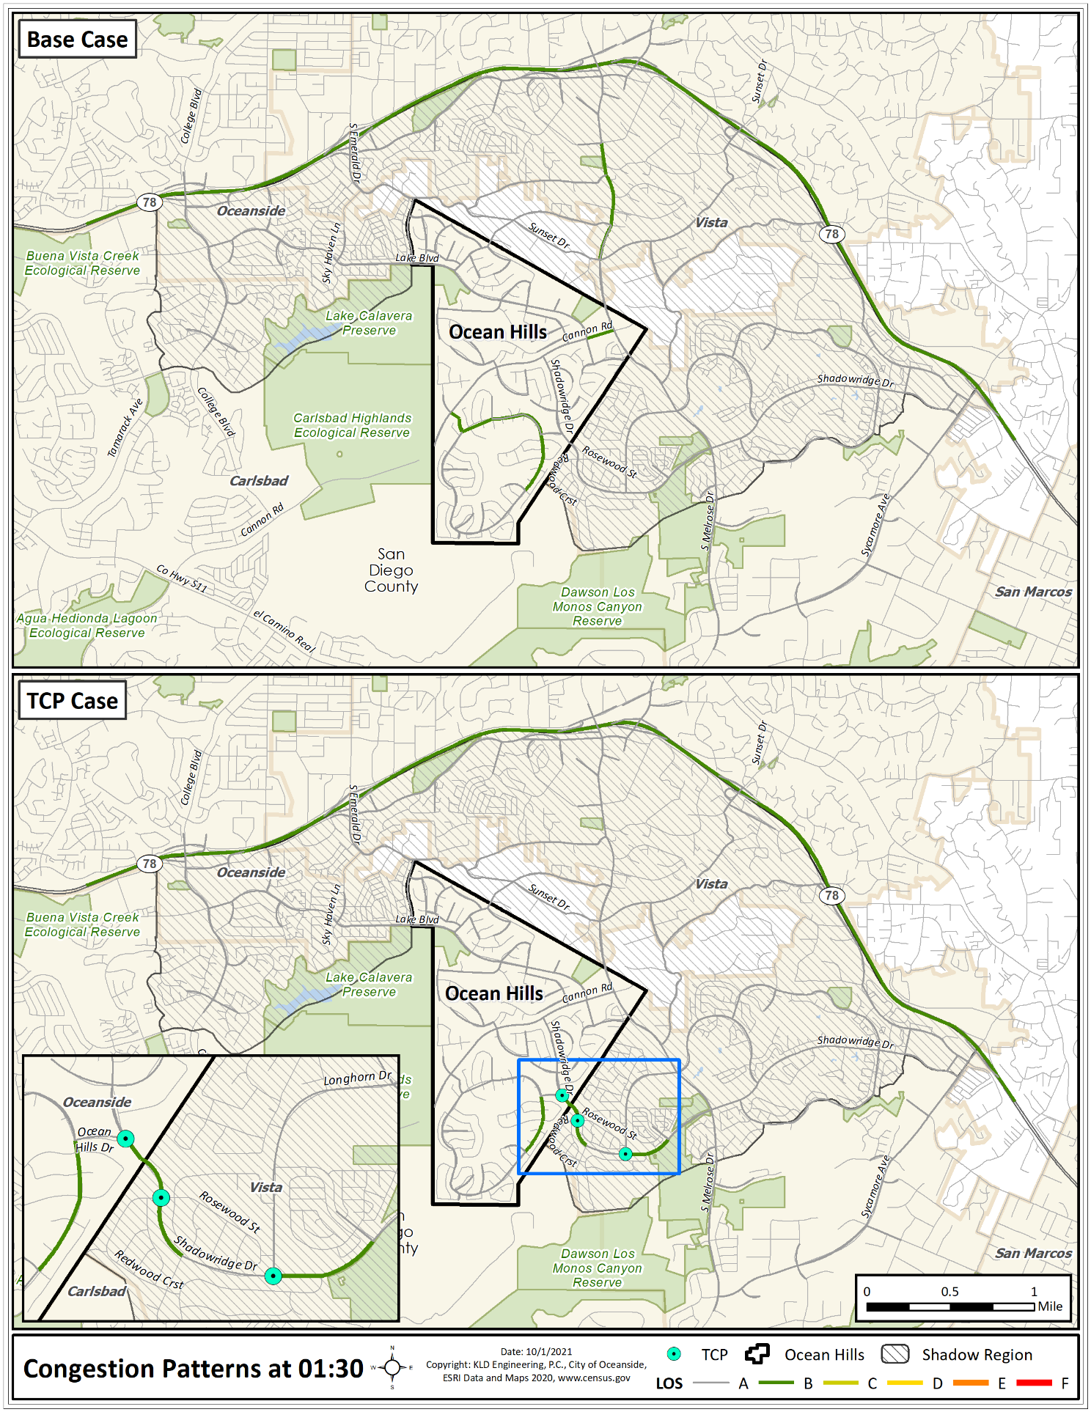
Figure II-1. Traffic Control Point Locations and Congestion Patterns

APPENDIX III – Transportation Resources

As discussed in KLD TR-1222, there are several population groups that may require transportation assistance to evacuate:
- Transit-dependent population: a demographic survey of the Ocean Hills population identified 69 individuals who do not own or have access to a private vehicle for evacuation. Buses have a typical capacity of 60 adults; however, during an evacuation, passengers will likely have luggage or personal items with them that may take up the rest of the seat they are sitting in. Thus, bus capacities are roughly half, or 30 adults. Three buses are needed to evacuate this population group.
- Medical facilities: there are also 179 people living within the two nursing homes in Ocean Hills. There are 90 individuals who are ambulatory and would require a bus, 85 individuals who are wheelchair bound and would require a wheelchair transport, and two individuals who are bedridden and would require an ambulance. These individuals would require four buses (30 passengers per bus), six wheelchair buses (15 passengers per bus) and two ambulances (2 passengers per ambulance) to evacuate.
- Schools and daycares: as discussed in Section 9, schoolchildren walk, bike or are driven by parents to school. In an emergency, these children will likely walk home, bike home, or be picked up by parents. Some emergencies may require students to be evacuated by bus. There are a total of 2,625 students within Ocean Hills. In an emergency where buses are needed for an evacuation, a total of 48 buses would be required to evacuate all schools and daycares. This is assuming 50 students per school bus for middle and high schools and 70 students for elementary school and lower.
- Those with access and functional needs: as discussed in Section 11, there are 483 individuals with access and functional needs. Of the 483 people, 82 individuals would require a bus, 106 individuals a medical van, 259 individuals a wheelchair accessible vehicle, 24 individuals an ambulance and 12 individuals would require other functional transportation vehicle. To evacuate these individuals, it would require 3 buses (30 passengers per bus), 8 medical vans (15 passengers per van), 18 wheelchair buses (15 passengers per bus) and 12 ambulances (2 passengers per ambulance)

The total resources needed to evacuate the Neighborhood of Ocean Hills are summarized in Table III-1 below.

Mutual aid agreements should be established with transportation companies, neighboring communities/county, or the state to provide transportation resources and operators in an emergency. Operators should be trained periodically on bus routes, pick-up points and shelter/reception center locations. Existing routes, pick-up points and operators should be leveraged to the extent practical. The time needed to mobilize resources through mutual aid should be considered. Care should be taken not to double count transportation resources and operators. For example, if Acme Bus Company has 10 total buses and several HOAs establish mutual aid with Acme Bus Company for those 10 buses, there would be a shortfall of resources in an emergency if all the HOAs were impacted by the emergency.

Table III-1. Transportation Resources Needed
Population Group | Transportation Resources
 | Buses | Medical Van | Wheelchair  Buses | Ambulances
Transit-Dependent Population | 3 | 0 | 0 | 0
Medical Facilities | 4 | 0 | 6 | 2
Schools | 48 | 0 | 0 | 0
Access and Functional Needs | 3 | 8 | 18 | 12
TOTAL: | 58 | 8 | 24 | 14

APPENDIX IV – Supporting Plans, References & Letters of Agreement/Memorandums of Understanding

Supporting Plans/Studies
1. Neighborhood of Ocean Hills Wildfire Evacuation Study, KLD TR-1222
2. Others to be filled in by stakeholders?
3.
4.
5.

References
1. County of San Diego Operational Area Emergency Operations Plan, Sept. 2018
2. City of Oceanside Emergency Operations Plan 2016
3. DHS Planning Considerations: Evacuation and Shelter-in-Place, July 2019
4. FEMA Improving Public Messaging for Evacuation and Shelter‐in‐Place, April 2021
5. Criteria for Development of Evacuation Time Estimate Studies (NUREG/CR-7002, Rev. 1), February 2021

Letters of Agreement/Memorandums of Understanding
1. To be established by stakeholders – transportation assistance
2. To be established by stakeholders – temporary and emergency shelters
3.
4.
5.

https://landfire.gov/

